Fundamentals of Data Science – Assignment Documentation

Module Code: UFCFK1-15-0

Module Title: Fundamentals of Data Science

Student Name: Praful Tiwari

Submission Date: 07-July-2025

## Program 1: Read from “students.csv”

Description:

This program reads a CSV file named `students.csv` and prints the contents. The fields include name, ID, course, level, and section. It uses Python's built-in `csv` module to handle reading structured data.

Screenshot:

## Program 2: Append User Input to “students.csv”

Description:

This program takes user input for student details (name, ID, course, level, section) and appends the new record to the existing `students.csv` file.

Screenshot:

## Program 3: Arithmetic on a List of Numbers with File Logging

Description:

This program allows the user to input a list of numbers, performs addition, subtraction, multiplication, and division, and writes the results to a file with the current date and time. The operation is repeated until the user chooses to exit, at which point the full file content is displayed.

Screenshot:

## Program 4: Copy File Contents with Exception Handling

Description:

The program reads contents from one file and writes them to another. The file names are input by the user. Proper exception handling is implemented for missing input files and overwriting output files.

Screenshot:

## Program 5: Student Class – Object Instantiation and Display

Description:

This program defines a `Student` class with attributes like ID, name, address, admission year, level, and section. It creates an instance, takes input for each attribute, and displays the data.

Screenshot:

## Program 6: Recipe and RecipeBook Classes

Description:

Defines a `Recipe` class with ID, name, ingredients, and description. A `RecipeBook` class manages multiple `Recipe` instances. The program demonstrates basic OOP principles like encapsulation and object collection handling.

Screenshot:

## Program 7: Employee Class with File Storage

Description:

Implements an `Employee` class with various attributes and writes employee details to `employees.csv`. It also includes functionality to list all employees and uses exception handling.

Screenshot:

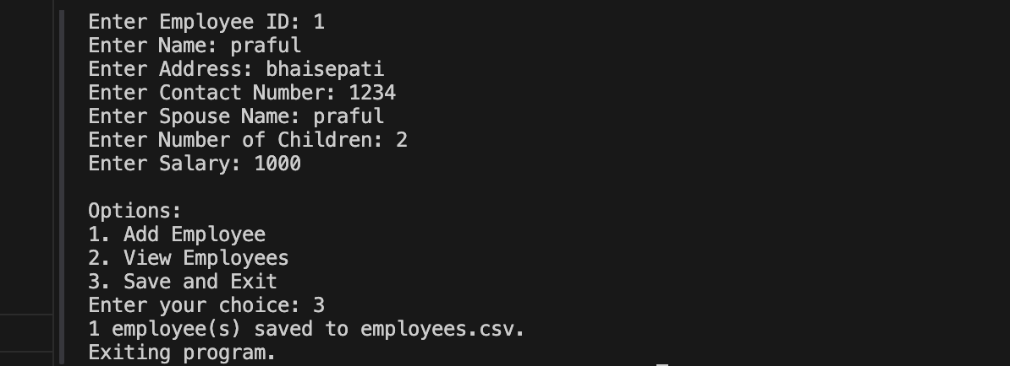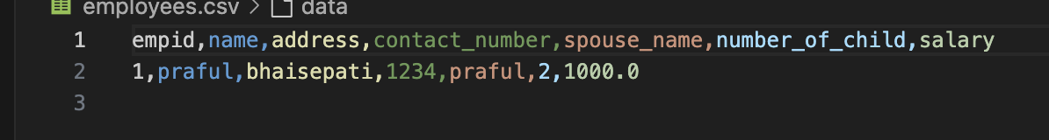

## Program 8: Library Book Management System

Description:

This program implements a basic library management system with functionalities to issue, return, and search for books. It uses classes and file handling for data storage and exception handling for robustness.

Screenshot:

